

LAB EXPERIMENTS
Slot C-COMPILER DESIGN(CSA1402)
NAME: DEEPTHI K REGNO:192524211
PROGRAM 1:
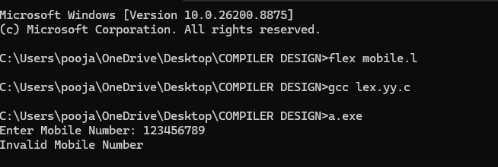

PROGRAM 2:
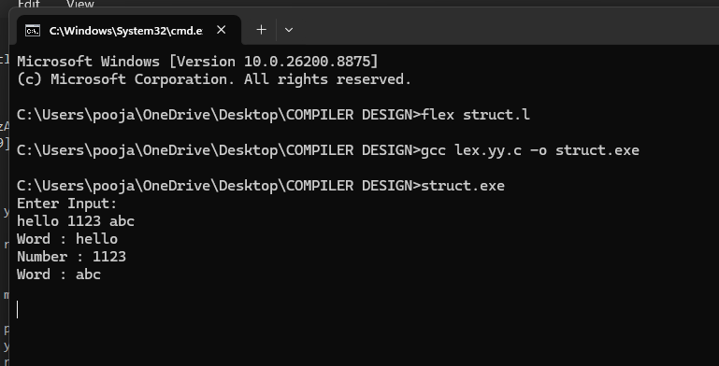

PROGRAM 3:
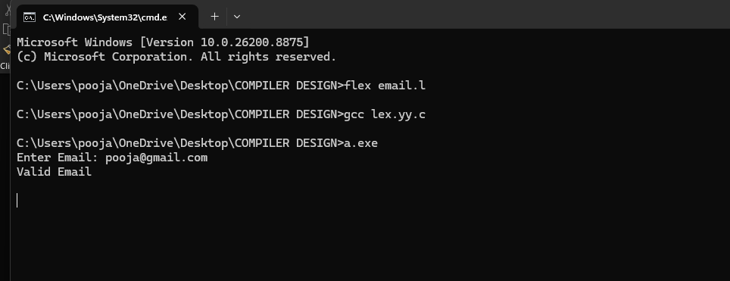
PROGRAM 4:
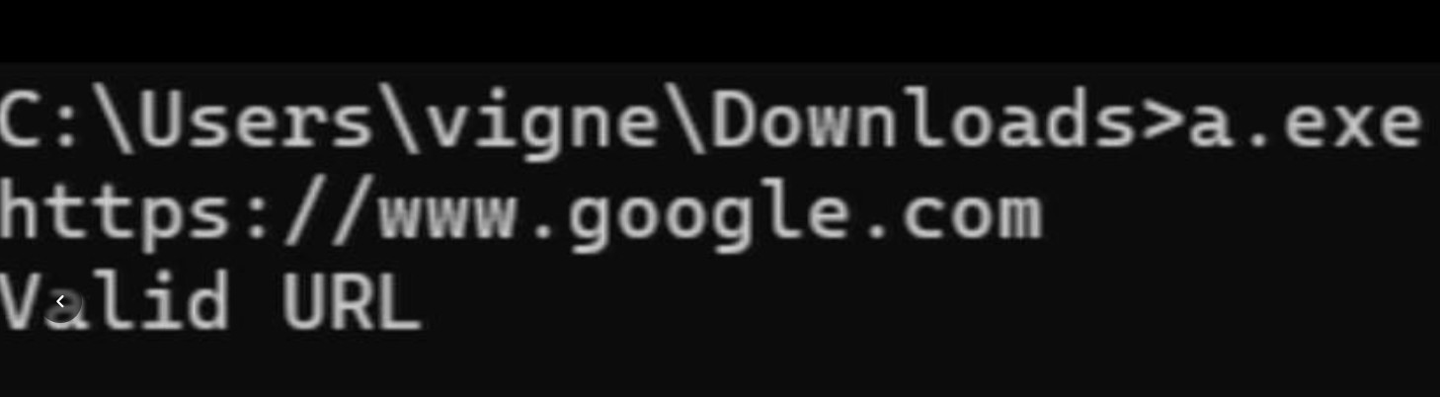

PROGRAM 5:
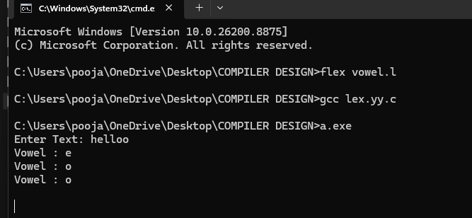

PROGRAM 6:
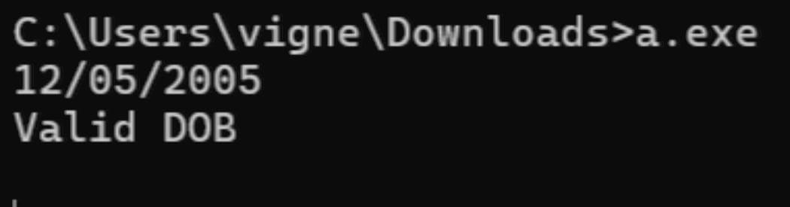

PROGRAM 7:
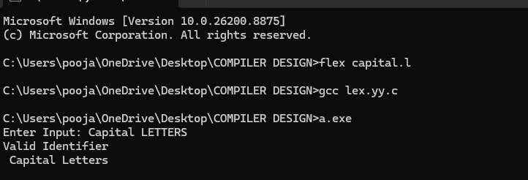
GIT HUB IMAGE:

